Outline

1. **Background**
2. **The 2018 questionnaire: overview**
3. **Questionnaire results (majority of questions)**
4. **Open Data**
5. **Implementation of the Fundamental Principles: challenges and opportunities (Part 11 questions/answers)**
6. **Concluding remarks**
7. **Annex with survey results (table format)**
8. **Background**

Following a request at the thirty-fourth session of the Statistical Commission, the Statistics Division conducted a first global review of the implementation of the Fundamental Principles of Official Statistics in 2003. The results were reported to the Commission in a report to its thirty-fifth session in 2004, coinciding with the tenth anniversary of the adoption of the Fundamental Principles by the Commission.

At its forty-second session, the UN Statistical Commission “agreed that it was desirable to conduct periodic reviews of the implementation of the Fundamental Principles by Member States and asked the United Nations Statistics Division to undertake such a review and report the results to the Commission before 2014” (Decision 41/111). This request was reaffirmed during the forty-third session in 2012 (Decision 43/111).

The United Nations Statistical Commission, at its 48th session in March 2017, requested the Friends of the Chair Group on the Implementation of the Fundamental Principles of Official Statistics (FOC-FPOS)[1] to work on selected dimensions of the implementation of the Fundamental Principles within the context of the preparation for the twenty-fifth anniversary of their adoption, in 2019. Specifically, the Group was mandated to conduct a global review of the implementation of the Fundamental Principles of Official Statistics[2] and to prepare a report to be discussed at the Commission’s 50th session in March 2019.

1. **Assessment questionnaire on the implementation of the Fundamental Principles of Official Statistics**

The present assessment of the implementation of the Fundamental Principles of Official Statistics is based on an updated version or the questionnaires sent to countries by the UN Statistics Division in 2003 and 2012.[3] It has been prepared with the contribution of PARIS21, with the aim to modernize and improve on previous assessments, while maintaining comparability on a set of core items from the 2012 questionnaire to allow for the review of progress. Notable differences include revised and expanded options for each answer based on the FPOS implementation guide and the results of previous questionnaires. The wording of some questions was also revised with a view to improve consistency in the responses, since the 2012 report highlighted some contradictions across the answers provided by some respondents. The 2018 questionnaire also included new questions related to open data and the application of the Fundamental Principles to non-official and non-traditional sources of data, to better reflect the current situation of national statistical offices and their use of information from an expanded data ecosystem.

There were 73 questions included in the 2018 questionnaire, compared to 78 in the 2012 version. Many of the questions in the 2012 assessment were yes/no, so for the 2018 questionnaire the answers to those questions were included as answer options to better pinpoint trends in implementation activities.

Ninety-three countries responded to the 2018 questionnaire with a regional breakdown as follows:

*Respondents by region (percentage)*

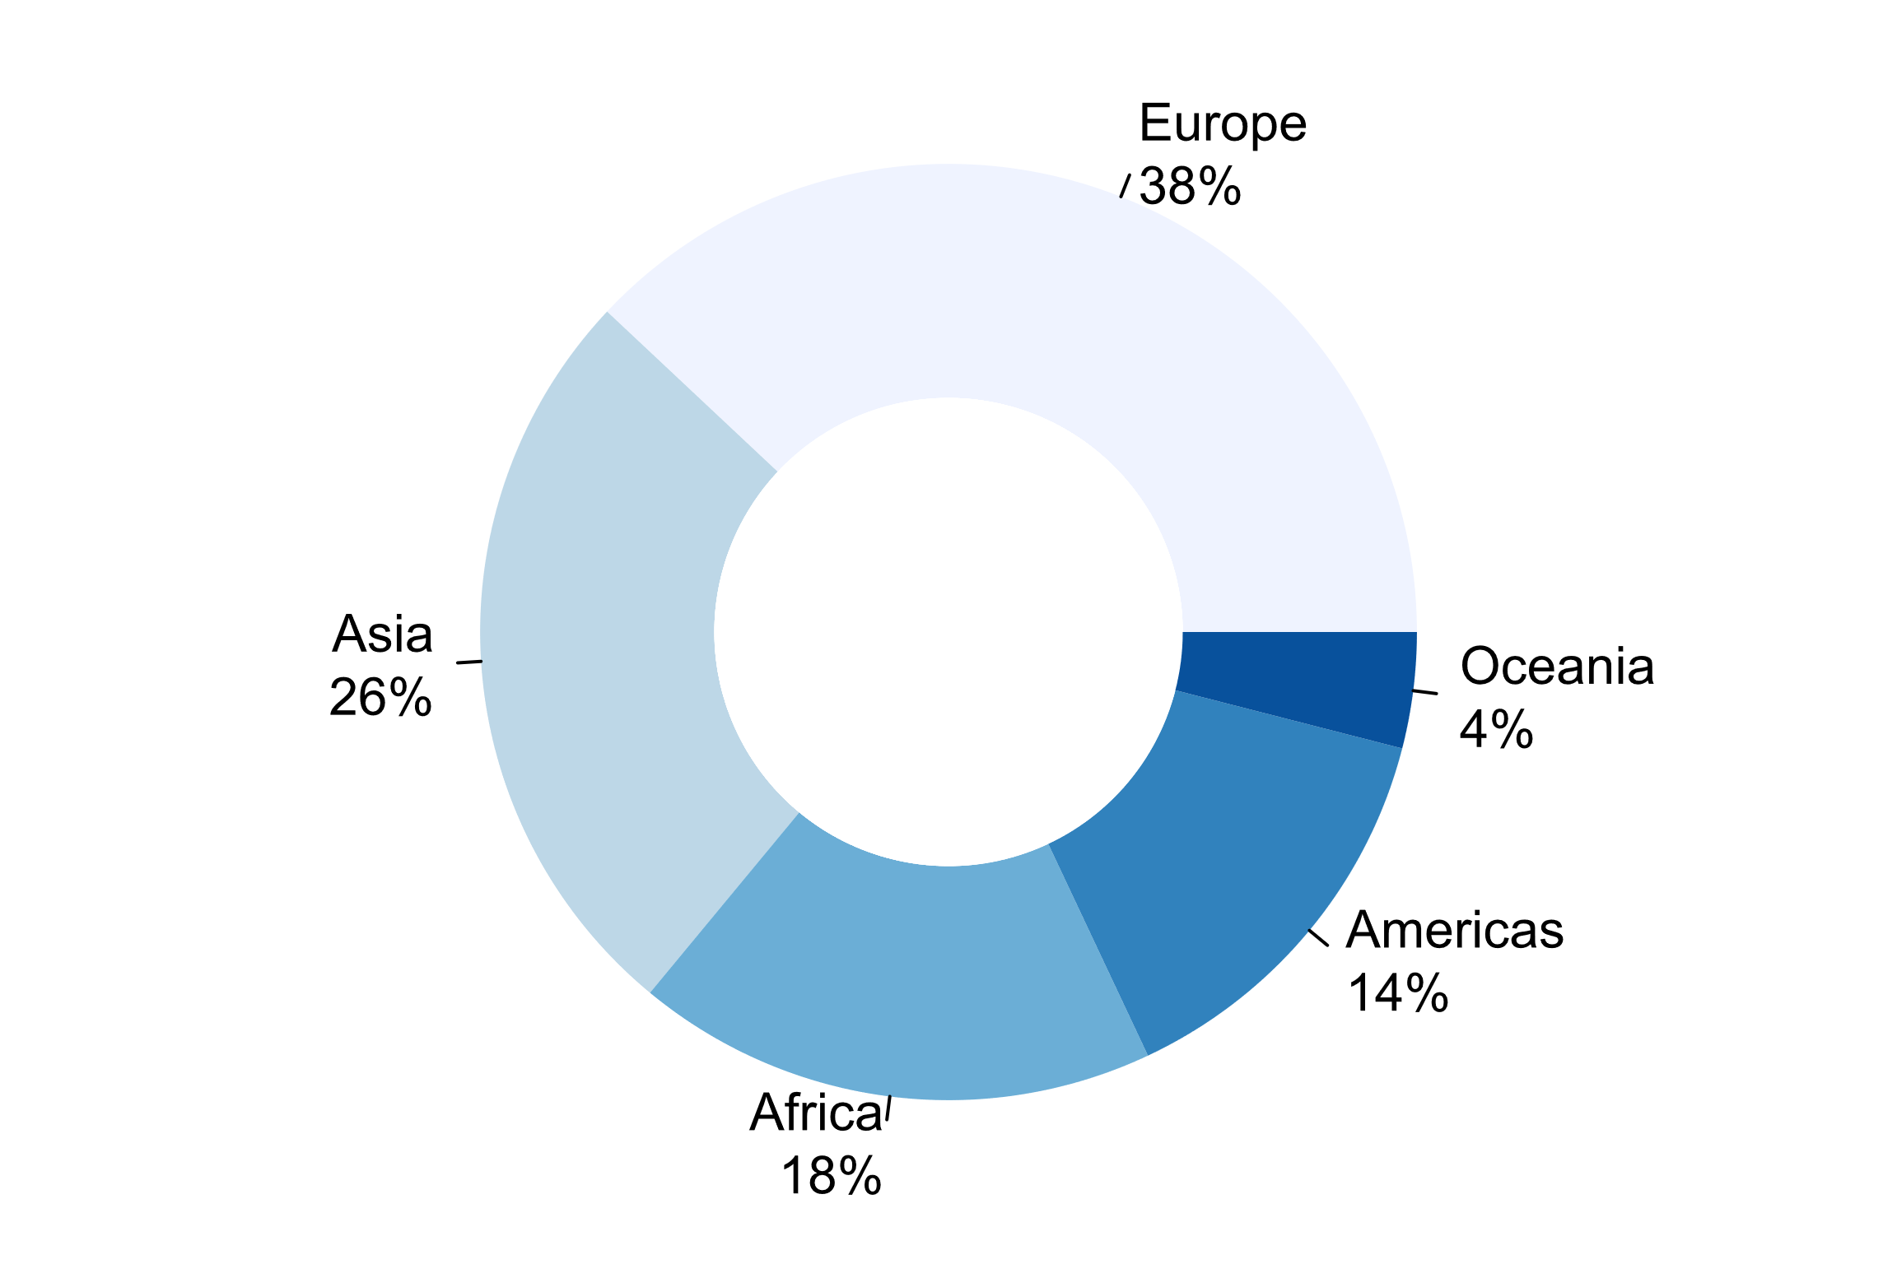

For the 2018 survey, approximately 86 per cent of the 93 country respondents answered on behalf of the national statistical office (NSO), while about 12 per cent answered for the national statistical system (NSS). This response rate per NSO and NSS is consistent with the 2012 survey. To fully understand the impact of implementation of the FPOS within the broader NSS, future questionnaires may delve into more specific questions on NSS activities and the FPOS.

*Awareness of existence UNFPOS*

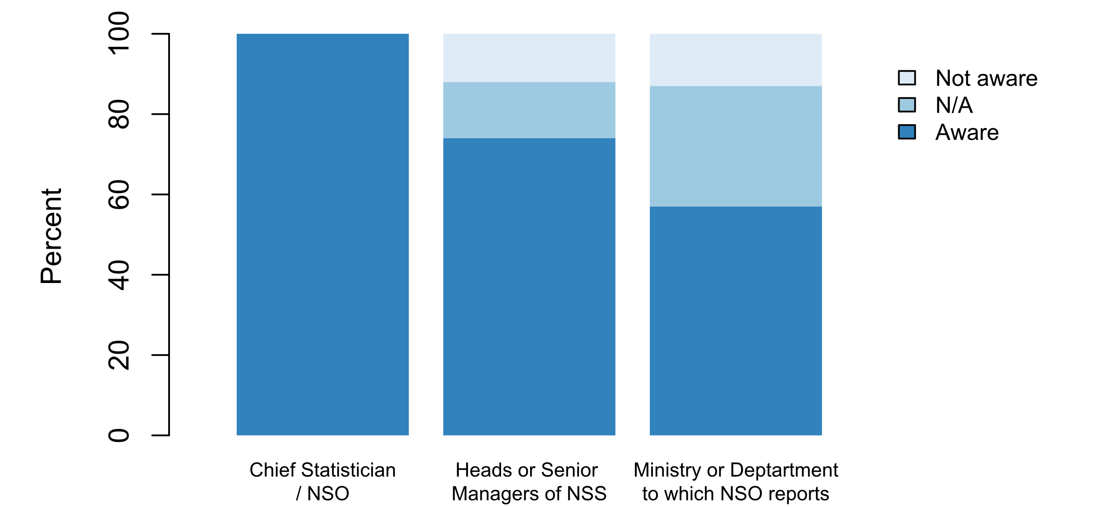

However, in only 74 percent of the responses indicate that the heads or senior management of other agencies of the National Statistical System are aware of them. Moreover, only 57 percent of countries indicated that the line ministry or department to which the NSO reports is aware of the UNFPOS.

For over 60 per cent of respondents, the UNFPOS is fully integrated in statistical law or legal framework, whereas about 27 per cent of respondents note the UNFPOS is partially integrated in statistical law or legal framework. About 8 per cent of respondents note that the UNFPOS is not integrated in statistical law or legal framework. This information was previously included as part of an answer to a related question in the 2012 questionnaire, but not explicitly asked, so it was added in the 2018 questionnaire.

1. **Main questionnaire results**

**Principle 1: Relevance, Impartiality and Equal Access**

*User engagement: Honouring citizens’ entitlement to public information*

Previous surveys on the implementation of the UNFPOS show that the proportion of countries that report the existence of established user councils and organized user groups for specific surveys and/or to ensure user-producer dialogues had increased from 66 percent in 2003 to 72 percent in 2012. To provide a better insight on the this and other mechanisms for user engagement, the 2018 assessment included a question on the sources of feedback employed by NSO to gather information on user needs and user satisfaction with respect to statistical products and services in the past five years. Based on the results, user councils still serve a function for garnering user feedback, alhtough other mechanisms such as user workshops/stakeholder coordination meetings, user satisfaction surveys and website traffic analysis were identified as more widely used. Additional sources for feedback from users included analysis of information requests.

*How was feedback from users on statistical products and services (e.g. needs, satisfaction) sought in the past five years? (multiple)*

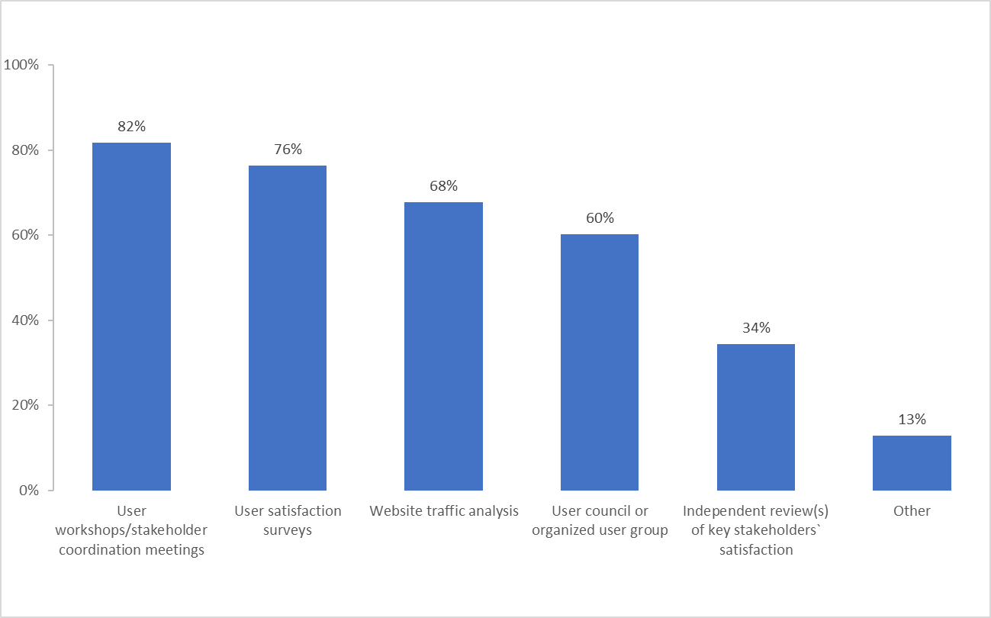

*Question 1.1a/1.1b*

Of the 60 per cent of countries with user councils, the mandate for the councils is primarily strategic advice on statistical policies and priorities, followed by coordination of statistical activities and technical advice. For one country, it was stated that user councils provide strategic advice, while user groups provide technical advice. Over half of the stakeholders that participate in the user councils or organized user groups are government employees, academia and professional associations. Between 40 and 48 per cent are comprised of civil society organizations, policy-makers and business networks.

*Question 1.4*

In the past questionnaires (2012 and 2003), almost 90 per cent of countries reported having a systematic dissemination policy. In order to better understand what types of dissemination measures are in place in countries, the following question was adjusted to include examples that were given in the previous questionnaires. The 2018 results show that almost all of the 93 respondent countries use various dissemination media, such as print publications, online pdf files, etc. And a vast majority (90 per cent) appoint a specialized unit responsible for dissemination or provide user support via email, etc. In past questionnaires, an advanced release calendar was an element of a dissemination strategy which was mentioned in responses. While this is still a component (83 per cent), it is clear from the responses that other measures are also essential measures in place for disseminating statistics currently.

|  |  |  |  |
| --- | --- | --- | --- |
| 1.4 | Which of the following measures are currently in place for disseminating statistics? (multiple) | Count | % |
|  | Using various dissemination media, such as print publications, online pdf files, etc. | 91 | 97.8 |
|  | Appointment of a specialized unit responsible for dissemination at the NSO | 84 | 90.3 |
|  | Providing user support via e-mail, written correspondence or telephone | 84 | 90.3 |
|  | Providing online data for exploration by general users (interactive online database interfaces, fully formatted excel files) | 78 | 83.9 |
|  | Publishing an advanced release calendar, announcing when various statistics will be published | 77 | 82.8 |
|  | Providing data downloads in proprietary formats for data analysis software (e.g, Excel, Access, Stata, SAS, SPSS) | 69 | 74.2 |
|  | Publishing catalogues of available publications, documents, and other services | 68 | 73.1 |
|  | Pursuing a dissemination/communications strategy | 66 | 71.0 |
|  | Providing data downloads in open machine-readable formats (such as CSV, XML, JSON) | 54 | 58.1 |
|  | Providing online access to data via APIs | 35 | 37.6 |
|  | Other | 3 | 3.2 |

*Question 1.6*

Pre-release of statistics to certain user groups was not granted to any of the groups listed for 47 per cent of the respondent countries. Forty-four per cent noted that government departments/policy-makers do in fact have access to statistics prior to their public release. Over 50 per cent of the time the users were always publicly identified. Comments provided on this question note that for a number of countries specific policies regarding pre-release are established and found online and in general, those that receive the pre-release do so about 24 hours in advance. In the 2012 questionnaire these questions yielded contradictory results regarding pre-release, with eighty per cent stating statistics were made available to all users at the same time and then two-thirds also confirming that government departments were given access to statistics prior to release.

*In the past five years, which groups of users were given access to statistics prior to their public release?*

*In the past five years, which groups of users were given access to statistics prior to their public release?*

*Question 1.7a, b, c*

The accessibility of data for all users and under free circumstances is part of the open data initiative. In order to more clearly pinpoint the circumstances in which national statistical offices are allowing access to microdata and under what conditions, the following questions were added to the 2018 questionnaire[4]. For about 60 per cent of respondents, aggregates and/or microdata available online is accessible under publicly available terms of use; can be re-distributed and derivative works based on the data can be distributed under condition of attribution of the source.

*Challenges in the implementation of Principle 1*

In general, for Principle 1, main challenges identified by respondents (question 1.8) included: ensuring equal access to statistical information; the inclusion or exclusion of microdata and ensuring that aggregates do not identify people or groups; in the short and medium term harmonizing legal frameworks with the statistical framework; as well as harmonizing administrative records for statistical and geographical purposes to increase timeliness of dissemination and reduce costs of data capture, the generation of information and lessen the burden of the system’s informants.

**Principle 2: Professional Standards, Scientific Principles and Professional Ethics[5]**

*Question 2.2, 2.3*

In 2018, 86 per cent reported to have clear rules for the appointment and dismissal of the head of the NSO – an increase from approximately 75 per cent from the 2012 results. In the past five years, only a few of the national statistical offices (less than 7 per cent) received inquiries about the chief statistician selection process.

|  |  |  |  |
| --- | --- | --- | --- |
| 2.2 | Are there clear rules for the appointment and dismissal of the head of the NSO? (single) | No. | % |
|  | Yes | 80 | 86 |
|  | No | 13 | 14 |

*Question 2.6*

One hundred percent of the countries reported that there are documents that provide guidelines on professional ethics, with the majority of countries stating the statistical law and internal regulations and staff rules are the primary guidance documents. This is an improvement from the 2012 results, where only 80 per cent of statistical offices reported they had written guidelines for professional ethics. Ten per cent also identified other documents that provide guidelines other than existing codifications.

*Which document(s) provide(s) guidance on professional ethics for staff?*

*Question 2.7*

In all but one of the countries, measures were taken in the past five years to inform and remind staff about professional ethics. More that three-quarters conduct orientation and training programmes and seminars. New staff from six out of every ten countries get sworn in and receive relevant laws and guidelines.

*Question 2.9*

Ninety-three per cent of the national statistical offices have staff that have received training concerning open data, data privacy or access to information policies and principles.

|  |  |  |
| --- | --- | --- |
| 2.9 | Have any staff of the NSO received training concerning open data, data privacy or access to information policies and principles? | % |
|  | Yes | 92.6 |
|  | No | 7.4 |

*Have any staff of the NSO received training concerning open data, data privacy or access to information policies and principles?*

*Question 2.10*

To the best of their knowledge, 70 per cent of the respondents indicated that other agencies in their national statistical system have received training concerning open data, data privacy or access to information policies and principles. Twenty-five per cent of the respondents indicated that other agencies have not. The remaining five per cent did not give an answer. For those that have not received training, the reasons include limited finances, lack of personnel and capacity and that open data is not yet operations.

*Challenges in the implementation of Principle 2*

In general, for Principle 2, main challenges identified by respondents (question 2.11) included: the need to update/reform the statistical law to guarantee professional and technical independence and code of ethics; lack of training and lack of knowledge in this area by line ministries; areas of data governance; inadequate human and financial resources in this area; and improving transparency and accountability by statistical agencies.

**Principle 3: Accountability and Transparency[6]**

*Question 3.2*

Eighty-six per cent of respondents provide information on the quality of published data through methodological notes and 82 per cent have quality information as part of metadata. This is in line with a growing trend found in the 2012 results of a shift to more routine and standardized formats for informing about the quality of published data.

|  |  |  |  |
| --- | --- | --- | --- |
| 3.2 | How are users currently informed of the quality of published data, e.g. adequacy of the source data, biases the data may have, response rates, non-response and its treatment, imputations?   (multiple) | Count | % based on 93 |
|  | Via methodological notes | 80 | 86.0 |
|  | As part of metadata provided with the data | 76 | 81.7 |
|  | Via quality reports | 51 | 54.8 |
|  | In meetings to address data quality | 50 | 53.8 |
|  | Other | 6 | 6.5 |
|  | None of the above | 3 | 3.2 |

*Question 3.3*

Published data of all the national statistical offices responding to the 2018 questionnaire are accompanied by some sort of explanatory texts. For 82 per cent of the respondents, metadata is associated with each dataset. Almost 80 per cent notify their users of major methodological changes and 61 per cent provide an erratum or other forms of error correction.

|  |  |  |  |
| --- | --- | --- | --- |
| 3.3 | What types of explanatory texts accompany published data? (multiple) | Count | % based on 93 |
|  | Metadata associated with each dataset | 76 | 81.7 |
|  | Notifications of major methodological changes | 74 | 79.6 |
|  | Erratum or any other form of error correction | 57 | 61.3 |
|  | Manuals and protocols used by the NSS | 48 | 51.6 |
|  | Guides on interpretation of data used and estimates | 44 | 47.3 |
|  | Other | 8 | 8.6 |
|  | None Of The Above | 0 | 0.0 |

*Question 3.3c*

For those country respondents (76) that selected metadata as the type of explanatory text that accompanies published data, almost 90 per cent noted that the proportion of the datasets released in the last two years included metadata at least half of the time.

*What proportion of the datasets released in the last two years by the NSO included metadata?*

*Question 3.4*

Almost 97 per cent of the countries use at least one data platform to disseminate statistical data. Forty-three per cent indicated that they use custom-developed data platforms.

|  |  |  |  |
| --- | --- | --- | --- |
| 3.4 | What data platforms(s) are currently being used by the NSS/NSO to disseminate statistical data? (multiple) | Count | % based on 93 |
|  | Custom-developed data platform | 40 | 43.0 |
|  | Other | 30 | 32.3 |
|  | ArcGIS | 29 | 31.2 |
|  | Eurostat web portal | 25 | 26.9 |
|  | OECD.Stat | 23 | 24.7 |
|  | NADA | 20 | 21.5 |
|  | DevInfo | 18 | 19.4 |
|  | Country STAT | 15 | 16.1 |
|  | African Information Highway | 12 | 12.9 |
|  | US/UK open source SDGs National Reporting Platform | 9 | 9.7 |
|  | Prognoz (Open Data Portal) & Knoema | 8 | 8.6 |
|  | IMIS | 5 | 5.4 |
|  | None Of The Above | 3 | 3.2 |

*Challenges in the implementation of Principle 3*

In general, for Principle 3, main challenges identified by respondents (question 3.5) included: lack of resources to produce recommended quality reports and metadata; and lack of metadata from other agencies in the NSS.

**Principle 4: Prevention of Misuse[7]**

*Question 4.1*

Over three-quarters of country respondents have reacted to the erroneous interpretation and misuse of statistics during the past five years, primarily through sending letters to the editors of newspapers or advertorials (59 per cent), publishing articles through webpages or social media (57 per cent) or holding press conferences or issues press releases (52 per cent). The most identified misuse over the past two years was the misreporting of findings. Similar to the results in 2012, problems of misinterpretation often are attributed to users’ lack of methodological knowledge, statistical literacy and awareness. These issues were also identified as the most challenging for countries when implementing this Principle.

|  |  |  |  |
| --- | --- | --- | --- |
| 4.1 | Has the NSO/NSS reacted to erroneous interpretation and misuse of statistics during the past five years? (single) | No. | % |
|  | Yes | 72 | 77.4 |
|  | No | 21 | 22.6 |

*Question 4.2*

|  |  |  |  |
| --- | --- | --- | --- |
| 4.2 | (if yes) How did the NSO/NSS System react? (multiple) | Count | % |
|  | Sending letters to the editors of newspapers or advertorials | 55 | 59.1 |
|  | Publishing articles on own webpage or posting on social media | 53 | 57.0 |
|  | Holding press conferences or issuing press releases | 48 | 51.6 |
|  | Other | 18 | 19.4 |

*Question 4.2a*

|  |  |  |
| --- | --- | --- |
| 4.2 | 4.2 (if yes) How did the NSO/NSS System react? (multiple) |  |
| 4.2a | What types of misuse were identified in the past two years? (multiple) | Count |
|  | Misreporting of findings*** | 59 |
|  | Overgeneralizations** | 34 |
|  | Selective reporting of findings (omitting key findings) | 29 |
|  | Suggesting false causality***** | 27 |
|  | Misleading graphs and data visualization**** | 19 |
|  | Leading questions* | 12 |
|  | Other | 5 |
|  | None of the above | 3 |

*Question 4.3*

Countries are engaging in a wide array of activities to educate data users, in line with results found also in the 2003 and 2012 questionnaires. In addition to the activities noted in the answer choices, countries also pointed out other activities such as: quizzes for users, hackathons, self-learning videos and statistical Olympics for high school students. Generally, seminars, participation in external events, and/or appearance in mass media activities were held twice or more per year by the majority of respondents.

*Which activities did the NSO/NSS carry out to educate data users in the past five years, including the media?*

*Challenges in the implementation of Principle 4*

In general, for Principle 4, main challenges identified by respondents (question 4.5) included: statistical literacy and awareness; and one country noted it is at the beginning of implementation since the statistical law was just created.

**Principle 5: Sources for Official Statistics[8]**

*Question 5.1*

Practically every national statistical office use sample surveys (99 per cent of the respondents) and/or administrative data (98 per cent) as one of their sources of data. On the other hand, only seven per cent uses citizen-generated data from civil society organizations. Other sources of data indicated: censuses (94 per cent of respondents); web scrapped data (37 per cent); privately-owned datasets (31 per cent); and satellite imagery (29 per cent).

*Which sources of data is the NSO currently using? (Note: Based on 93 respondents for individual options)*

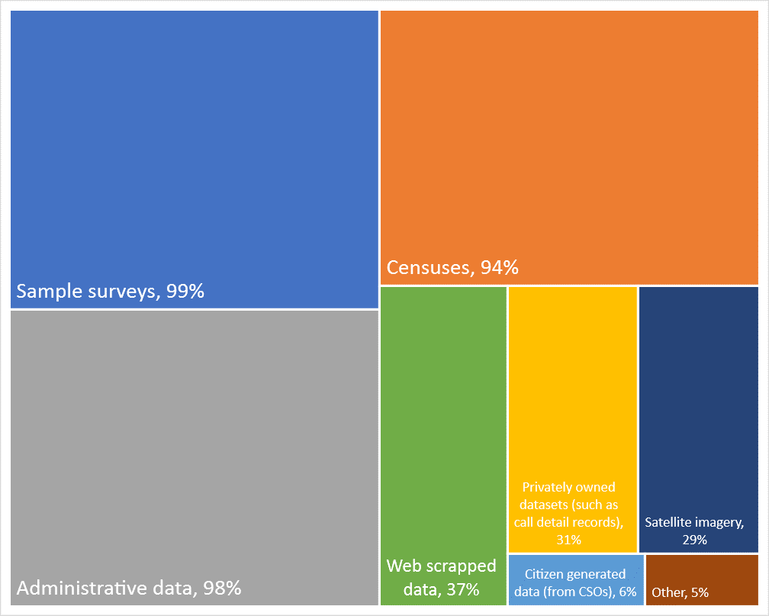

*Question 5.1b*

From the countries that use administrative data as one of their sources, virtually all (98 per cent) take action for adapting the records to statistical purposes. Eighty-seven per cent of them cooperate with the custodians at the stage of design or modernization of information systems; 81 per cent provide advice to the custodians; and 74 per cent give feedback to the data source when errors are detected.

|  |  |  |  |
| --- | --- | --- | --- |
| 5.1 | Which sources of data is the NSO currently using? (multiple) |  |  |
| 5.1b | (if "administrative data" was selected) What actions are being taken for adapting the records to statistical purposes from the source? (multiple) | Count | % based on 91 |
|  | Cooperation with custodians of administrative data at the stage of design/modernization of information systems | 79 | 86.8 |
|  | Providing advice to the custodians of administrative data for amending the composition of data and classification | 74 | 81.3 |
|  | Feedback with custodians of administrative data when errors are found | 67 | 73.6 |
|  | Training personnel of the custodians of administrative data | 42 | 46.2 |
|  | Other | 3 | 3.3 |
|  | None of the above | 2 | 2.2 |

*Question 5.1c*

From the 93 countries, 55 per cent indicated that they use web scrapped data, satellite imagery or privately-owned datasets as a source of data. Of those 55 per cent, two-thirds have specific rules of access and confidentiality measures to treat the datasets and over half (53 per cent) stated that the data provider does not contribute to methodological decisions regarding the use of the data. On the other hand, only 37 per cent can state that “consumers/citizens are informed that their data is being used for compiling official statistics”.

|  |  |  |  |
| --- | --- | --- | --- |
| 5.1 | Which sources of data is the NSO currently using? (multiple) |  |  |
| 5.1c | (if "web scrapped data, satellite imagery or privately-owned datasets" was selected) Please select the statements that apply to how the NSS accesses and uses big data or citizen-generated data (multiple) | Count | % based on 51 |
|  | There are specific rules of access and confidentiality measures to treat these datasets | 34 | 66.67 |
|  | The data provider (whether a CSO or private institution) does not contribute to methodological decisions regarding the use of the data | 27 | 52.94 |
|  | The NSS has a contract with the data provider | 23 | 45.10 |
|  | The private provider of data (e.g. mobile phone operator) has been selected after weighing alternatives | 21 | 41.18 |
|  | Consumers/citizens are informed that their data is being used for compiling official statistics | 19 | 37.25 |

*Question 5.3*

The national statistical offices use quality management frameworks. Forty-five per cent apply the Data Quality Assessment Framework; 43 per cent use the European Statistical System Quality Assurance Framework; 38 per cent use General Data Dissemination Syste;, and 23 per cent use Total Quality Management.

*Challenges in the implementation of Principle 5*

In general, for Principle 5, main challenges identified by respondents (question 5.5) included:

**Principle 6: Confidentiality[9]**

*Question 6.1:* all 93 country respondents state that there is a confidentiality provision in the laws that regulate the NSO/NSS, with 70 per cent noting that the confidentiality provision applies to the NSS in general and not just the NSO.

|  |  |  |  |
| --- | --- | --- | --- |
| 6.1a | If yes, does it apply to the NSO only or to the NSS in general? (single) | No. | % |
|  | NSS | 65 | 69.9 |
|  | NSO | 28 | 30.1 |

*Question 6.3*

*What practices are currently being implemented to anonymize statistical data?*

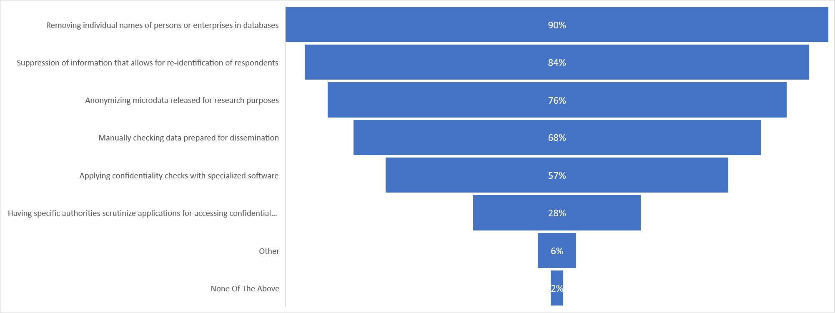

*Challenges in the implementation of Principle 6*

In general, for Principle 6, main challenges identified by respondents (question 6.5) included: More guidance in the recommendation about handling micro data and open data accessibility would be helpful. Consideration of the risks relating to equitable access when data is released by multiple sources; local population is too small, hence there is high probability of response fatigue among households for household surveys. Anonymizing data is also a challenge as it is easy to identify persons; there are some contradictions between other laws and the Statistics law.

**Principle 7: Legislation[10]**

*Question 7.1*

General statistics law practically exists in all countries, except for three of the respondents.

|  |  |  |  |
| --- | --- | --- | --- |
| 7.1 | Is there a general statistics law in your country? (single) | No. | % |
|  | Yes | 90 | 96.8 |
|  | No | 3 | 3.2 |

*Question 7.2*

In 97 per cent of the countries, there are regulations that cover the body responsible for statistics. Regulations in 94 per cent of the countries provide rules on the status, mandate and functions of the national statistical office. Approximately 92 per cent also indicated that regulations cover secrecy, confidentiality and privacy obligations.

|  |  |  |  |
| --- | --- | --- | --- |
| 7.2 | Which of the following aspects of the NSS are covered by regulations (e.g. Statistical Law, presidential decrees)? (multiple) | Count | % (based on 93) |
|  | The body responsible for statistics and its responsibilities | 90 | 96.77 |
|  | The status, mandate and functions of the NSO | 87 | 93.55 |
|  | Secrecy, confidentiality and privacy obligations (including sanctions for non-compliance) | 86 | 92.47 |
|  | Sanctions for not responding to mandatory statistical enquiries | 82 | 88.17 |
|  | The definition of official statistics | 78 | 83.87 |
|  | The role and status of the chief statistician | 78 | 83.87 |
|  | The coordination of statistical activities across government | 78 | 83.87 |
|  | Access to administrative data | 76 | 81.72 |
|  | The role and membership of the national statistical council | 67 | 72.04 |
|  | The staff of the NSO | 65 | 69.89 |
|  | The role and the responsibilities of agencies other than the NSO | 65 | 69.89 |
|  | The matters to be covered in the statistical work program | 62 | 66.67 |
|  | Participation in international statistical activities | 62 | 66.67 |
|  | Presumption of publication and the acceptable conditions for not publishing data collected | 38 | 40.86 |
|  | Other | 5 | 5.38 |
|  | None Of The Above | 0 | 0.00 |

*Question 7.4*

In most cases, the head of the national statistical office reports to the Ministry of planning or development (24 per cent of the respondents); the Prime Minister, chancellor or President (22 per cent); Ministry of finance or comptroller general (13 per cent); and Ministry of economic affairs, industry or trade (11 per cent).

*Question 7.5*

According to the results, Freedom of Information or Access to Information laws exists in 82 per cent of the countries. However, the national statistical system is not covered in 11 per cent of them.

|  |  |  |  |
| --- | --- | --- | --- |
| 7.5 | If the country has a Freedom of Information or Access to Information law, is the NSS covered by it? (single) | No. | % |
|  | Yes | 68 | 73.1 |
|  | No such law exists | 17 | 18.3 |
|  | No | 8 | 8.6 |
|  | Total | 93 | 100 |

*Question 7.6*

Close to 79 per cent of the respondents indicated that there are regulations affecting the functioning of the national statistical office published on the website.

|  |  |  |  |
| --- | --- | --- | --- |
| 7.6 | Are the regulations affecting the functioning of the NSOs published on the website? (single) | No. | % |
|  | Yes | 73 | 78.5 |
|  | No | 19 | 20.4 |
|  | NSO does not have a website | 1 | 1.1 |
|  | Total | 93 | 100 |

*Challenges in the implementation of Principle 7*

In general, for Principle 7, main challenges identified by respondents (question 7.7) included:

**Principle 8: National Coordination[11]**

*Question 8.1*

Ninety-one out of the 93 national statistical offices reported that at least one other agency in their country produces official statistics on behalf of the government. The two most popular other agencies identified were the statistical services of their country’s Central Bank (89 per cent) and statistical services in line ministries (86 per cent). Other producers identified were statistical offices at the sub-national level (47 per cent), public research institutes (24 per cent), statistical research and training centers (20 per cent), and supra-national bodies (e.g. Eurostat) (13 per cent). For 12 per cent of the respondents, some official statistics are produced by private institutions. Also, it is worth pointing out that for one of the two respondents that did not identify another agency that produces official statistics in addition to the national statistical office, their statistical law does allow for other institutions to produce official statistics upon request.

|  |  |  |  |
| --- | --- | --- | --- |
| 8.1 | Which agencies other than the NSO produce official statistics on behalf of the government in your country? (multiple) | Count | % based on 93 |
|  | Statistical services in the Central Bank | 83 | 89.2 |
|  | Statistical services in line ministries | 80 | 86.0 |
|  | Statistical offices at the sub-national level (region, province, etc.) | 44 | 47.3 |
|  | Public research institutions | 22 | 23.7 |
|  | Statistical research and training centers | 19 | 20.4 |
|  | Supra-national bodies (e.g. Eurostat) | 12 | 12.9 |
|  | Private institutions | 11 | 11.8 |
|  | Other | 7 | 7.5 |

*Question 8.2*

|  |  |  |  |
| --- | --- | --- | --- |
| 8.2 | What activities are currently being implemented for coordinating the NSS? (multiple) | Count | % based on 93 |
|  | Meeting in statistical committees, councils, etc. | 83 | 89.2 |
|  | Sharing of information and databases | 72 | 77.4 |
|  | Signing of memorandums of understanding between agencies | 70 | 75.3 |
|  | Developing joint training programmes | 58 | 62.4 |
|  | Preparing annual or multi-annual consolidated program of statistical activities | 49 | 52.7 |
|  | Monitoring duplication of work between agencies | 47 | 50.5 |
|  | Embarking in joint data collection | 42 | 45.2 |
|  | Performing regular quality reviews of statistical programs across the NSS | 29 | 31.2 |
|  | Reviewing and â€œclearingâ€ any planned data collection | 27 | 29.0 |
|  | Placement of NSO staff in other agencies | 25 | 26.9 |
|  | Exchanging staff between agencies | 21 | 22.6 |
|  | Sharing budget between statistical agencies | 17 | 18.3 |
|  | Other | 13 | 14.0 |
|  | None Of The Above | 1 | 1.1 |

*Question 8.3*

Meetings between agencies that produce official statistics of a country help with achieving an efficient national statistical system. More than 90 per cent of the respondents indicated that producers of official statistics have met at least once during the last five years with 75 per cent meeting twice or more per year and 12 per cent meeting annually.

*Question 8.5*

Based on the results, in countries where national statistical systems have different data producers, only 38 per cent reported having a central data portal where the official statistical data are published. For the 62 per cent that reported not having a central hub, many stated lack of resources and coordination amongst agencies as main reasons/challenges. It may also be worth noting that although a central data portal doesn’t exist, some respondents mentioned providing direct links to dissemination platform of the other agencies.

*Challenges in the implementation of Principle 8*

In general, for Principle 8, main challenges identified by respondents (question 8.6) included:

**Principle 9: Use of International Standards[12]**

*Question 9.1*

Eighty-eight per cent of the countries indicated that they currently use either 2008 SNA or 1993 SNA (68 per cent and 20 per cent, respectively).

|  |  |  |  |
| --- | --- | --- | --- |
| 9.1 | What version of the SNA is currently used in your country? | Count | % based on 93 |
|  | 2008 SNA | 63 | 67.74 |
|  | 1993 SNA | 19 | 20.43 |
|  | ESA 2010 | 4 | 4.30 |
|  | None | 2 | 2.15 |
|  | I don't know | 1 | 1.08 |
|  | Please see comment 9.1a | 1 | 1.08 |
|  | 1993 and 2008 | 1 | 1.08 |
|  | ESA2010 | 1 | 1.08 |

*Question 9.2*

Results show that only three per cent of the countries are not implementing the Principles and Recommendations for Population and Housing Censuses in their latest census programme. Seventy-two are implementing it fully while 25 per cent are partially implementing the Principles.

|  |  |  |  |
| --- | --- | --- | --- |
| 9.2 | To what extent are the Principles and Recommendations for Population and Housing Censuses, Rev. 3 (for census undertaken after 2015) or Rev. 2 (for census undertaken before 2015) being implemented in the latest census programme in your country? | No. | % |
|  | Fully | 67 | 72 |
|  | Partially | 23 | 24.7 |
|  | Not implemented | 3 | 3.2 |
|  | Total | 93 | 100 |

*Question 9.3*

The survey indicates that 37 per cent of the countries do not use the International Classification of Activities for Time Use Statistics 2016 (ICATUS 2016). Nineteen per cent of the national statistical offices use it to guide the collection of time-use data, 18 per cent use it for the dissemination of time-use statistics, regardless of the type of instruments used for data collection, and 14 per cent use it as the basis for national classifications of activities for time-use statistics.

|  |  |  |  |
| --- | --- | --- | --- |
| 9.3 | Does your country currently use the International Classification of Activities for Time Use Statistics 2016 (ICATUS 2016)? (multiple) | Count | % based on 93 |
|  | Time use is not compiled | 34 | 36.56 |
|  | To guide the collection of time-use data | 18 | 19.35 |
|  | For the dissemination of time-use statistics, regardless of the type of instruments used for data collection | 17 | 18.28 |
|  | As the basis for national classifications of activities for time-use statistics | 13 | 13.98 |
|  | None of the above | 34 | 36.56 |

*Question 9.4*

According to the results of the survey, 46 per cent of the national statistical offices have compiled and published at least one Environmental-Economic Account. Eight per cent have compiled but not yet published and 15 per cent have not compiled but have a started or planned a programme. On the other hand, 31 per cent of the countries indicated that they do not have a programme on EEA.

|  |  |  |  |
| --- | --- | --- | --- |
| 9.4 | Does your country have a programme on EEA*? (single) | Count | % |
|  | Yes, we have compiled and published at least one EEA | 43 | 46.2 |
|  | No, we do not have a programme on EEA | 29 | 31.2 |
|  | We plan (or have started) a programme on EEA, but do not yet compile any EE | 14 | 15.1 |
|  | Yes, we have compiled (or are compiling) at least one EEA but it has not be | 7 | 7.5 |
|  | Total | 93 | 100 |

*Question 9.5*

Seventy-one per cent of the respondents stated that they use SDMX in some statistical domains or data sets at the very least. Two of the respondents did know if SDMX was currently being used in their country.

*Does your country currently use SDMX?*

*Challenges in the implementation of Principle 9*

In general, for Principle 9, main challenges identified by respondents (question 9.6) included:

**Principle 10: International Cooperation[13]**

*Question 10.1*

All respondents reported being engaged in international cooperation activities. Close to 96 per cent participate in international working groups and approximately 93 per cent are in working groups at the regional level. Most national statistical offices also engage in technical cooperation activities (89 per cent) and training of statistical personnel (89 per cent). Seventy-three per cent also in peer reviews and/or external evaluations and 47 per cent are twinning (peer to peer collaboration).

|  |  |  |  |
| --- | --- | --- | --- |
| 10.1 | What types of international cooperation activities does the NSS engage in? (multiple) | No. | % (93 respondents) |
|  | Participation in international working groups | 89 | 95.7 |
|  | Participation in regional working groups | 86 | 92.5 |
|  | Technical cooperation | 83 | 89.2 |
|  | Training of statistical personnel | 83 | 89.2 |
|  | Peer reviews and/or external evaluations | 68 | 73.1 |
|  | Twinning (peer to peer collaboration) | 44 | 47.3 |
|  | Other | 6 | 6.5 |

*Question 10.3*

Most of the respondents (65 per cent) receive support from donors and just a little over half of them (53 per cent) stated that there is a donor coordination mechanism in place or a basket fund for statistics.

*If your country receives support from donors, is there a donor coordination mechanism in place or a basket fund for statistics?*

*Question 10.4*

Sixty per cent of the national statistical offices participate in or contribute to entities or partnerships whose purpose is to promote open data.

|  |  |  |  |
| --- | --- | --- | --- |
| 10.4 | Does the NSO participate in or contribute to any organization or partnership whose purpose is to promote open data? (single) | No. | % |
|  | Yes | 56 | 60.2 |
|  | No | 37 | 39.8 |

*Challenges in the implementation of Principle 10*

In general, for Principle 10, main challenges identified by respondents (question 10.5) included:

1. **Open Data**
2. **Implementation of the Fundamental Principles: challenges and opportunities (Part 11 questions/answers)**
3. **Concluding remarks**
4. **Annex with questionnaire results (table format)- *only the mandatory and additional questions included in the report***

1. This Friends of Chair Group was mandated by the Statistical Commission at its 48th session in March 2017 (Decision 48/107). The Friends of the Chair Group on the Fundamental Principles of Official Statistics was constituted in February 2018, comprising senior statisticians from 11 countries (Argentina, Australia, Egypt, Italy, Jordan, Malaysia, Mauritius, New Zealand, Poland, Suriname, and the United Kingdom of Great Britain and Northern Ireland) and seven international agencies and organizations as observers. New Zealand is Chair of the Group, with the Statistics Division acting as secretariat.
2. See <https://unstats.un.org/unsd/dnss/gp/FP-New-E.pdf>
3. See Report of the Secretary-General on Implementation of the Fundamental Principles of Official Statistics (E/CN.3/2004/21) and (E/CN.3/2013/3) available at <http://unstats.un.org/unsd/dnss/gp/globreview.aspx> and <https://unstats.un.org/unsd/statcom/44th-session/documents/doc13/2013-3-FundamentalPrinciples-E.pdf> respectively. See also the background document with further information on the 2012 questionnaire results which accompanies E/CN.3/2013/3 available at: <https://unstats.un.org/unsd/statcom/doc13/BG-FP.pdf>.
4. If aggregates and/or microdata are available online, under what conditions is access available? a) Data can be accessed…?, b) Anonymized microdata data and aggregates can be re-distributed…?, c) Derivative works based on the data can be distributed…?
5. FPOS Principle 2: “To retain trust in official statistics, the statistical agencies need to decide according to strictly professional considerations, including scientific principles and professional ethics, on the methods and procedures for the collection, processing, storage and presentation of statistical data.”
6. FPOS Principle 3: “To facilitate a correct interpretation of the data, the statistical agencies are to present information according to scientific standards on the sources, methods and procedures of the statistics.”
7. FPOS Principle 4: “The statistical agencies are entitled to comment on erroneous interpretation and misuse of statistics.”
8. FPOS Principle 5: “Data for statistical purposes may be drawn from all types of sources, be they statistical surveys or administrative records. Statistical agencies are to choose the source with regard to quality, timeliness, costs and the burden on respondents.”
9. FPOS Principle 6: “Individual data collected by statistical agencies for statistical compilation, whether they refer to natural or legal persons, are to be strictly confidential and used exclusively for statistical purposes.”
10. FPOS Principle 7: “The laws, regulations and measures under which the statistical systems operate are to be made public.”
11. FPOS Principle 8: “Coordination among statistical agencies within countries is essential to achieve consistency and efficiency in the statistical system.”
12. FPOS Principle 9: “The use by statistical agencies in each country of international concepts, classifications and methods promotes the consistency and efficiency of statistical systems at all official levels.”
13. FPOS Principle 10: “Bilateral and multilateral cooperation in statistics contributes to the improvement of systems of official statistics in all countries.”